For the scatter diagram.I choose the related coefficient as the metric.I suppose that the ‘handle bugs’ have positive correlation with release interval.So the r should > 0

For the v4.1

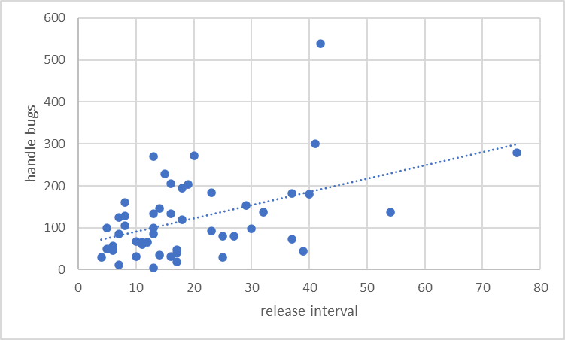

r=0.466,r>0.3,It means that the handle bugs and release interval has the media positive relationship.

For the v4.14

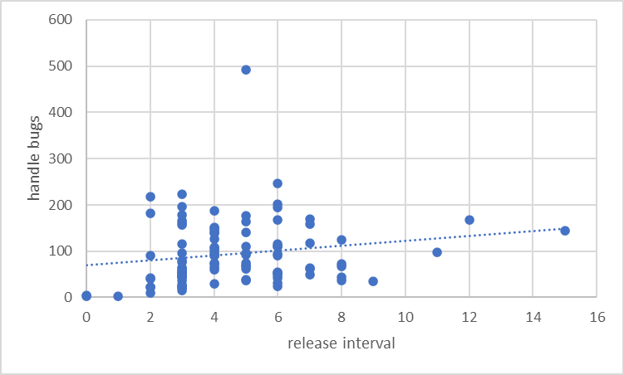

r=0.175<0.3,It means hat the handle bugs and release interval has the weak positive relationship

For v419

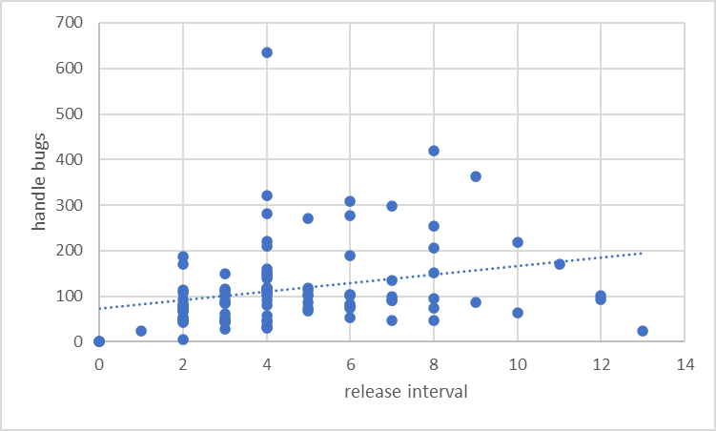

r=0.257,r<0.3,It means hat the handle bugs and release interval has the weak positive relationship

For v4.4

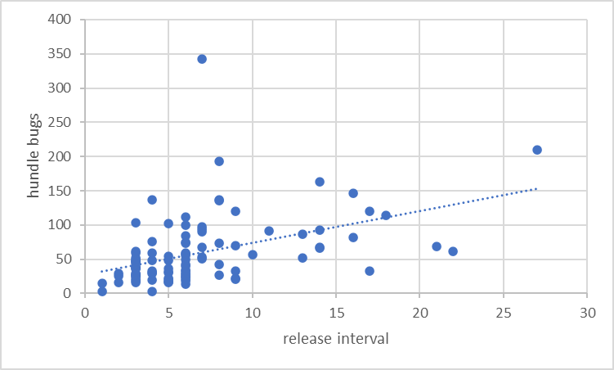

r=0.444,r>0.3,It means that the handle bugs and release interval has the media positive relationship.

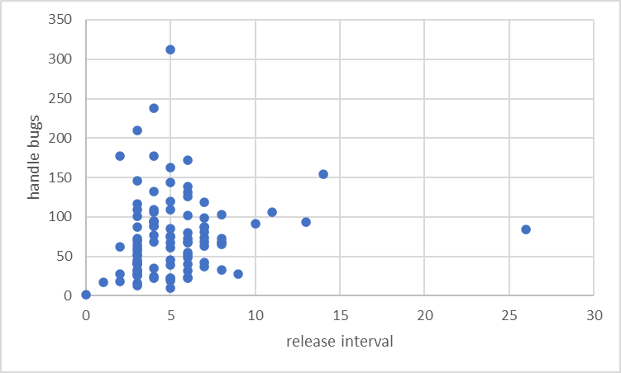

r=0.121,r<0.3,It means that the handle bugs and release interval has the weak positive relationship.

**Conclusion**

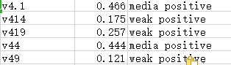

There are positive relationship between handle bugs and release interval.But this relationship is not strong.